**Sequence Diagram: Group Participation**

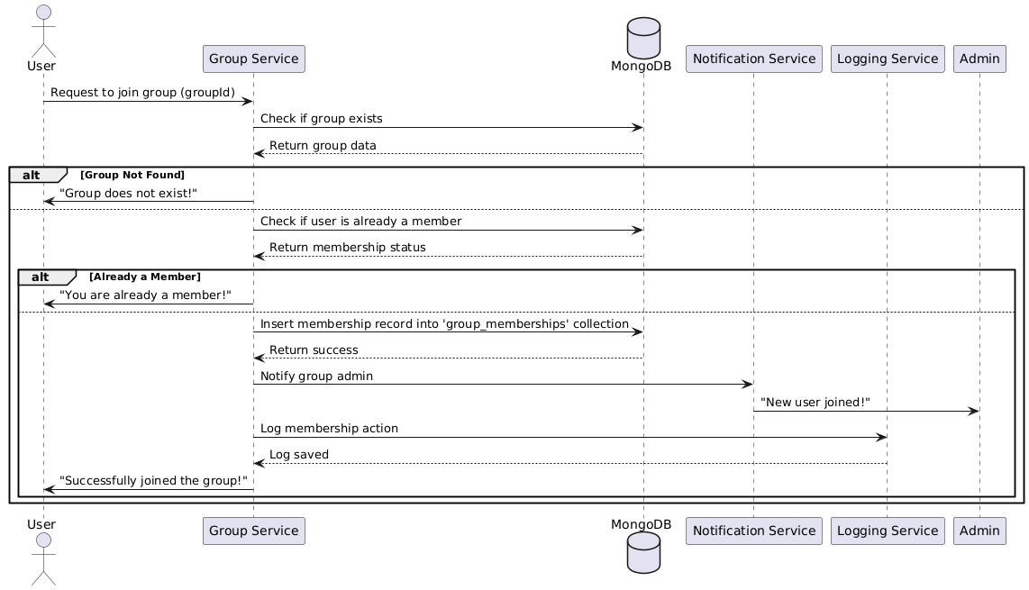

**Database**

**Functional Requirements (FRs)**

**FR1:** The system shall allow users to join groups.

**FR2:** The system shall allow group admins to manage memberships (approve/reject users for private groups).

**FR3:** The system shall support different roles within a group (member, admin).

**FR4:** Users shall be able to leave a group at any time.

**Non-Functional Requirements (NFRs)**

**NFR1:** The system should process membership requests in less than 3 seconds.

**NFR2:** The system shall support at least 1 million users per group.

**NFR3:** Group role changes should be logged for security and auditing purposes**.**